SUPER 30
INTRODUCTION TO ROBOTICS AND INDUSTRY LANDSCAPE
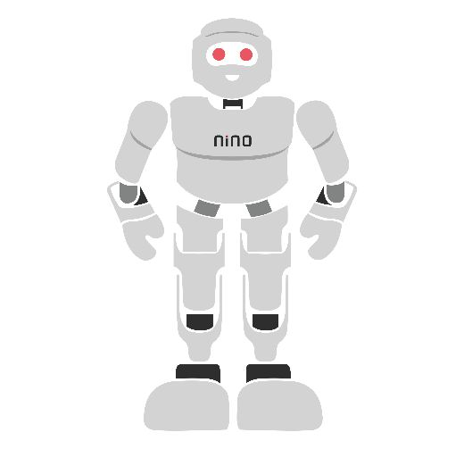

Module Overview
This module builds a complete theoretical foundation in robotics for learners with no prior background. It begins with what a robot is and how every robot follows the same sense–think–act cycle, then traces the history of robotics from early automata to today's humanoids, introduces the microcontrollers and computers that act as a robot's brain, and classifies the main robot families: wheeled, legged, humanoid and industrial. The module then surveys the global and Indian robotics industry, its segments, trends and career roles, and closes with the Sirena Technologies product ecosystem: UBot, NINO, the Perro quadruped, the Twist multi-legged robot and the biped and humanoid platforms. The topics below are organised as self-contained sections rather than fixed time slots, so pace can flex per batch; taught end-to-end, the full set of topics is designed to fill approximately 4 hours of theory instruction.

# | Topic | Learning Focus
1 | Introduction to Robotics | Define a robot; sense–think–act; robot components
2 | History of Robotics | Key milestones and the technologies behind them
3 | Types of Microcontrollers | MCU architecture; Arduino, ESP32, STM32, RP2040; SBC and edge AI
4 | Types of Robots | Wheeled, legged, humanoid, and industrial robots
5 | Robotics Industry Overview | Value chain, segments, major players, trends, careers
6 | Sirena Technologies Product Ecosystem | UBot, NINO, Perro, Twist, biped and humanoid platforms
7 | Summary and Review | Key takeaways, glossary and review questions

Learning Outcomes
On completing this module, the learner will be able to:
- Explain what makes a machine a robot using the sense–think–act model.
- Identify the main components of a robot and the role each plays.
- Describe the major milestones in the history of robotics and the technology that enabled each one.
- Compare common microcontroller families and distinguish a microcontroller from a single-board computer and an edge-AI module.
- Differentiate wheeled, legged, humanoid, and industrial robots by locomotion, stability, and application.
- Describe how the robotics industry is organised, its main segments, trends and career roles.
- Describe each platform in the Sirena Technologies ecosystem and the robotics concepts it demonstrates.

1. Introduction to Robotics

1.1 What Is a Robot?
A robot is a machine that can sense its surroundings, decide what to do using a program, and act on the physical world, with some degree of independence from a human operator. The word covers a wide range of machines: a vacuum cleaner that maps a living room, a six-axis arm welding car bodies, a delivery robot moving through a university corridor, and a humanoid that greets visitors and answers questions.
Robotics is the engineering field that designs, builds, programs and operates such machines. It is deeply interdisciplinary: mechanical engineering gives the robot its body, electronics gives it sensors, power and control circuits, computer science gives it software and intelligence, and mathematics ties these together through geometry, kinematics and control theory.

1.2 The Sense–Think–Act Model
Every robot, however simple or advanced, repeats the same three-step loop many times every second. Understanding this loop is the single most useful idea in introductory robotics, because every later topic – sensors, microcontrollers, motors, robot types – fits into one of its three steps.
- Sense – sensors convert physical quantities such as distance, light, tilt, sound or touch into electrical signals that a computer can read.
- Think – a controller (a microcontroller or computer) runs a program that turns sensor readings into decisions. The program may be a single if–else statement or a large artificial-intelligence model.
- Act – actuators such as motors, servos, grippers, speakers and lights carry out the decision and change the robot or its environment.
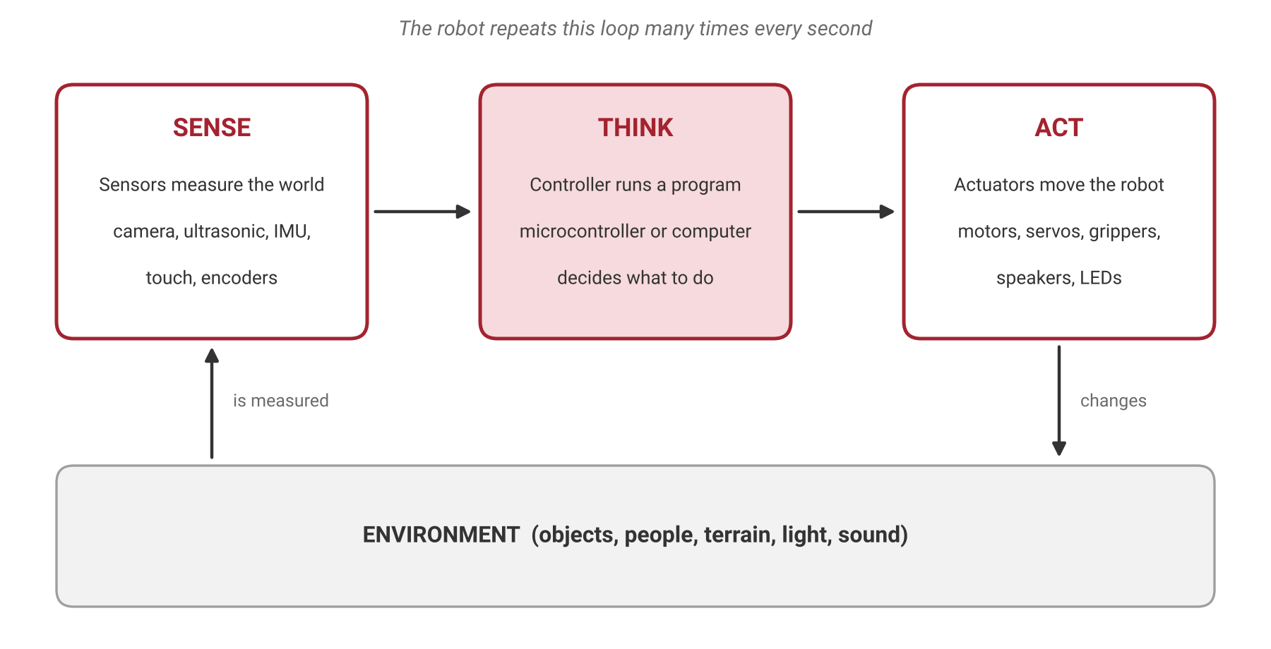
Figure 1.1: The sense–think–act loop. The robot measures its environment, decides, acts, and then measures the result of its own action.
Consider a person touching a hot pan. The skin senses heat, the brain decides that it is dangerous, and the arm muscles pull the hand away. A robot vacuum cleaner works the same way: a bump sensor senses a wall, the controller decides to turn, and the wheel motors change direction.

1.3 Robot, Automation or Remote Control?
Many machines contain motors and electronics without being robots. The sense–think–act model gives a clear test: if any one of the three parts is missing, or if a human performs the thinking step, the machine is better described as automation or teleoperation.
Machine | Senses? | Thinks for itself? | Acts? | Classification
Washing machine on a fixed timer | Limited | No – fixed sequence | Yes | Automation
Remote-controlled toy car | No | No – a human decides | Yes | Teleoperation
Robot vacuum cleaner | Yes | Yes | Yes | Robot
Drone with automatic height hold | Yes | Partly | Yes | Semi-autonomous robot
Industrial welding arm | Yes (joint encoders) | Yes – runs a program | Yes | Industrial robot

Robots also differ in their level of autonomy. A teleoperated robot is driven by a person in real time; a semi-autonomous robot handles some tasks itself (such as balancing) while a person gives high-level commands; a fully autonomous robot plans and carries out its task on its own. Sirena's UBot, for example, is described as both an autonomous and a semi-autonomous service robot, because it can be driven from a mobile app or perform tasks with less supervision.

1.4 Main Components of a Robot
Although robots look very different from one another, almost all of them are built from the same six building blocks connected around a central controller.
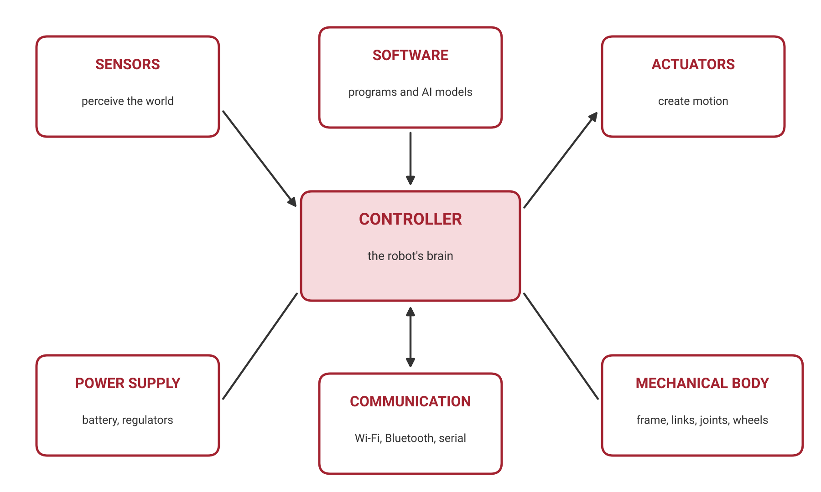
Figure 1.2: The building blocks of a robot arranged around the controller.
- Controller – the brain that runs the program; usually a microcontroller, a single-board computer, or both (Section 3).
- Sensors – the robot's senses, which measure the world and the robot's own state.
- Actuators – the robot's muscles, which create motion or output.
- Power supply – batteries, chargers, and voltage regulators that keep every part running safely.
- Mechanical body – the frame, links, joints, wheels or legs that carry everything and decide how the robot can move.
- Software and communication – the programs, AI models and wireless or wired links (Wi-Fi, Bluetooth, USB, serial) through which the robot is programmed and controlled.

1.5 Sensors and Actuators at a Glance
Sensors are commonly grouped into proprioceptive sensors, which measure the robot itself (joint angles, wheel rotation, tilt), and exteroceptive sensors, which measure the outside world (distance, images, sound). Good robot design always considers a sensor's range, resolution, update rate, and the situations in which it fails.
Sensor type | What it measures | Typical example | Common robot use
Distance (ultrasonic, IR, LiDAR) | How far an object is | HC-SR04, Sharp IR sensor | Obstacle detection, mapping
Inertial measurement unit (IMU) | Acceleration, rotation, heading | MPU-9250 (used in NINO) | Balance, tilt and orientation
Encoder | Rotation of a wheel or joint | Optical or magnetic encoder | Odometry, joint position
Camera | Images and video | USB or CSI camera | Object detection, navigation
Touch/force | Contact and pressure | Capacitive touch pad, bumper | Interaction, collision detection
Microphone | Sound | Microphone array | Voice commands
Environmental | Temperature, humidity, gas, light | DHT11, LDR | Monitoring, smart buildings

Actuator | How it moves | Strength | Typical robot use
DC motor | Spins continuously; speed set by PWM | Simple, efficient | Wheels of mobile robots
Hobby servo motor | Moves to and holds an angle | Easy position control | Legs of small quadrupeds and hexapods
Smart servo | Angle control plus feedback of position, load, and temperature over a data bus | Precise, networked | Humanoid joints (NINO uses Dynamixel smart servos)
Stepper motor | Moves in exact fixed steps | Accurate without feedback | 3D printers, CNC machines
Pneumatic/hydraulic | Compressed air or fluid pushes a piston | Very high force | Grippers, heavy industrial machines

1.6 Degrees of Freedom
A degree of freedom (DOF) is one independent way in which a robot or one of its parts can move. Each motorised joint usually adds one DOF. A simple two-wheeled robot moving on a floor has three DOF in the plane (forward–backward, sideways and rotation), though it can directly control only two of them. A typical industrial arm has six DOF, which lets it place a tool at any position and in any orientation within reach. Sirena's Perro quadruped and Twist robot each use 12 servo motors, and the NINO humanoid uses 20. More DOF give more flexibility but make the robot heavier, more expensive and harder to control.

1.7 Why Do We Build Robots?
Robots are used where they do a job better, more safely or more cheaply than people can. Engineers often summarise this as the three Ds: dull work (highly repetitive), dirty (unpleasant or unhygienic) or dangerous (toxic, hot, heavy or remote). Robots also add value where precision and consistency matter, such as electronics assembly and surgery, where scale matters, such as warehouses shipping millions of orders, and where interaction and learning matter, such as education and customer service, which is the main focus of Sirena's humanoid and legged platforms.

2. History of Robotics
The history of robotics is a story of bottlenecks being removed one by one: first actuation (how to move precisely), then computing (how to decide), then sensing (how to perceive), and most recently intelligence and balance (how to adapt and walk). Knowing this history explains why robots look the way they do today and why legged and humanoid robots arrived only recently.
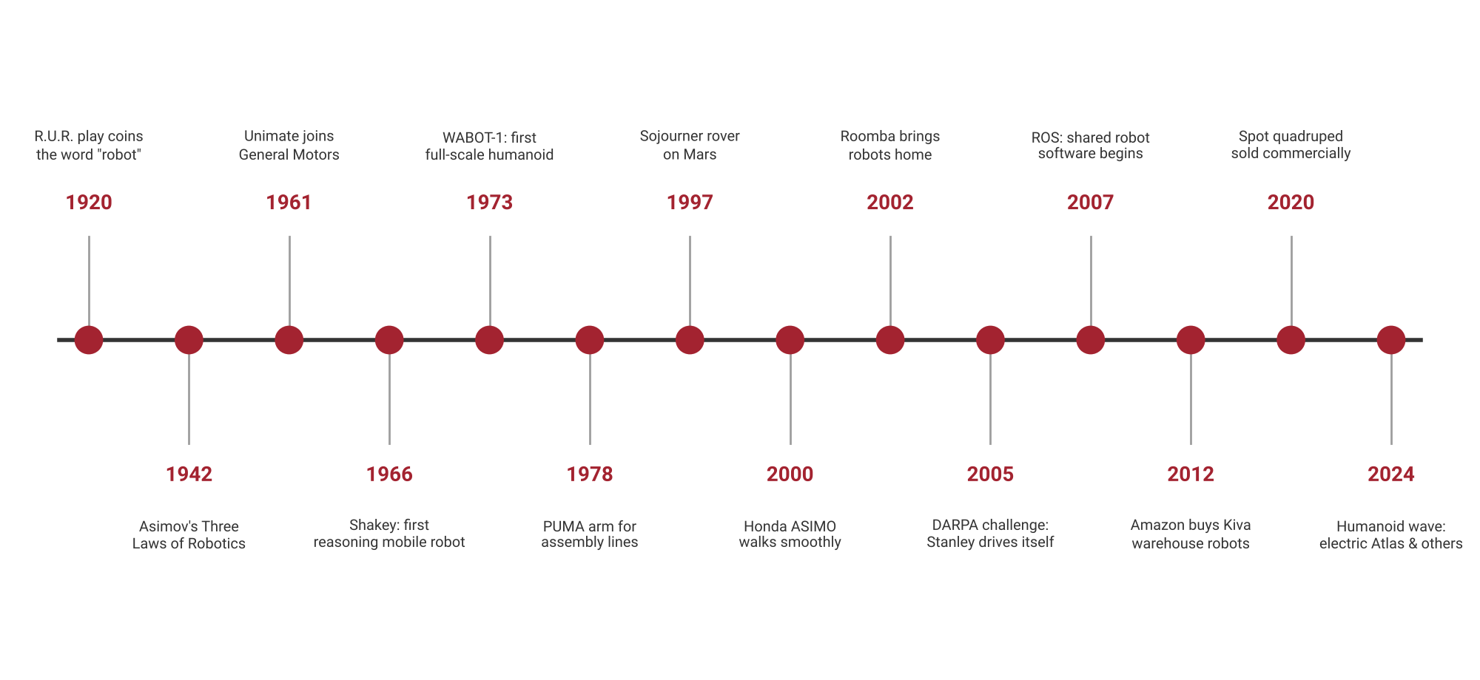
Figure 2.1: Selected milestones in the history of robotics, 1920–2024.

2.1 From Myths and Automata to the Word "Robot"
For centuries, inventors built automata: clockwork figures that wrote, played music, or imitated animals. They were mechanical marvels but followed a fixed sequence and could not sense or adapt, so they were not robots in the modern sense.
The word robot comes from Karel Čapek's 1920 play R.U.R. (Rossum's Universal Robots), from the Czech word robota, meaning forced labour. In 1942, the writer Isaac Asimov introduced his Three Laws of Robotics in the short story Runaround; Asimov is also credited with coining the word robotics. His laws were fiction, but they framed robot safety as a design problem, a question engineers still work on today.

2.2 The Industrial Era
Modern robotics began in the factory. George Devol patented a programmable transfer arm in the 1950s and, with Joseph Engelberger, founded Unimation. Their robot Unimate began work at a General Motors plant in 1961, lifting and stacking hot die-cast metal parts, a dull, dirty and dangerous job. This is why industrial arms remain the largest single category of robots.
- 1969 – Stanford Arm: an all-electric, computer-controlled arm that became the model for many later designs.
- 1973 – KUKA Famulus: among the first industrial robots with six electromechanically driven axes.
- 1978 – PUMA (Programmable Universal Machine for Assembly): a compact arm that spread robots into assembly work.

2.3 Mobile and Intelligent Robots
Moving robots out of fixed cells required sensing and onboard computing. Shakey (Stanford Research Institute, 1966–1972) was the first mobile robot able to reason about its own actions, combining a camera, range finder, and planning software. NASA's Sojourner rover explored Mars in 1997. In 2002, iRobot's Roomba brought an affordable robot into homes, proving that simple sensing and clever behaviour could be commercially successful.
The DARPA Grand Challenges for driverless vehicles marked a turning point: in 2004 no vehicle finished the desert course, but in 2005 Stanford's Stanley completed it, laying the foundations of self-driving cars. In 2007, work began on the Robot Operating System (ROS), which became a shared software toolkit for robots worldwide. In 2012, Amazon acquired Kiva Systems, whose shelf-carrying robots made mobile robots central to warehouse logistics.

2.4 The Legged and Humanoid Era
Walking is much harder than rolling because the robot must constantly manage its balance. Japan's WABOT-1 (Waseda University, 1973) was the first full-scale humanoid robot. Honda's ASIMO, unveiled in 2000, demonstrated smooth humanoid walking. Boston Dynamics' BigDog (2005) showed that a quadruped could keep its balance on rough ground, and its successor Spot went on commercial sale in 2020. In 2024, an all-electric version of the Atlas humanoid was unveiled, alongside a wave of humanoid robot start-ups worldwide.
In India, Sirena Technologies describes NINO as the first intelligent humanoid robot built by an Indian company, designed primarily for education. The enablers of this era were lighter and stronger motors, lithium batteries, low-cost IMUs, fast embedded processors and, increasingly, learned control and AI.

2.5 What History Teaches
Era | Bottleneck removed | Enabling technology | Example robots
Industrial (1960s–1980s) | Precise, repeatable motion | Electric and hydraulic actuators, early computers | Unimate, Stanford Arm, PUMA
Mobile and service (1990s–2010s) | Sensing and onboard decision-making | Cheap sensors, microcontrollers, batteries, ROS | Sojourner, Roomba, Stanley, Kiva
Legged and humanoid (2000s–today) | Dynamic balance and interaction | IMUs, smart servos, embedded AI, lithium batteries | ASIMO, Spot, Atlas, NINO

Each era did not replace the previous one; it added to it. Industrial arms, warehouse robots and humanoids all exist side by side today, each suited to different tasks.

3. Types of Microcontrollers

3.1 What Is a Microcontroller?
A microcontroller (MCU) is a complete, small computer on a single chip. It contains a processor core, program memory (flash), working memory (RAM), and a set of built-in peripherals that connect directly to the physical world: digital input/output pins, analogue-to-digital converters, timers for generating pulses, and communication interfaces. Because everything is on one chip, a microcontroller is cheap, uses very little power, starts instantly, and reacts within microseconds, which makes it ideal for the "think" step closest to sensors and motors.
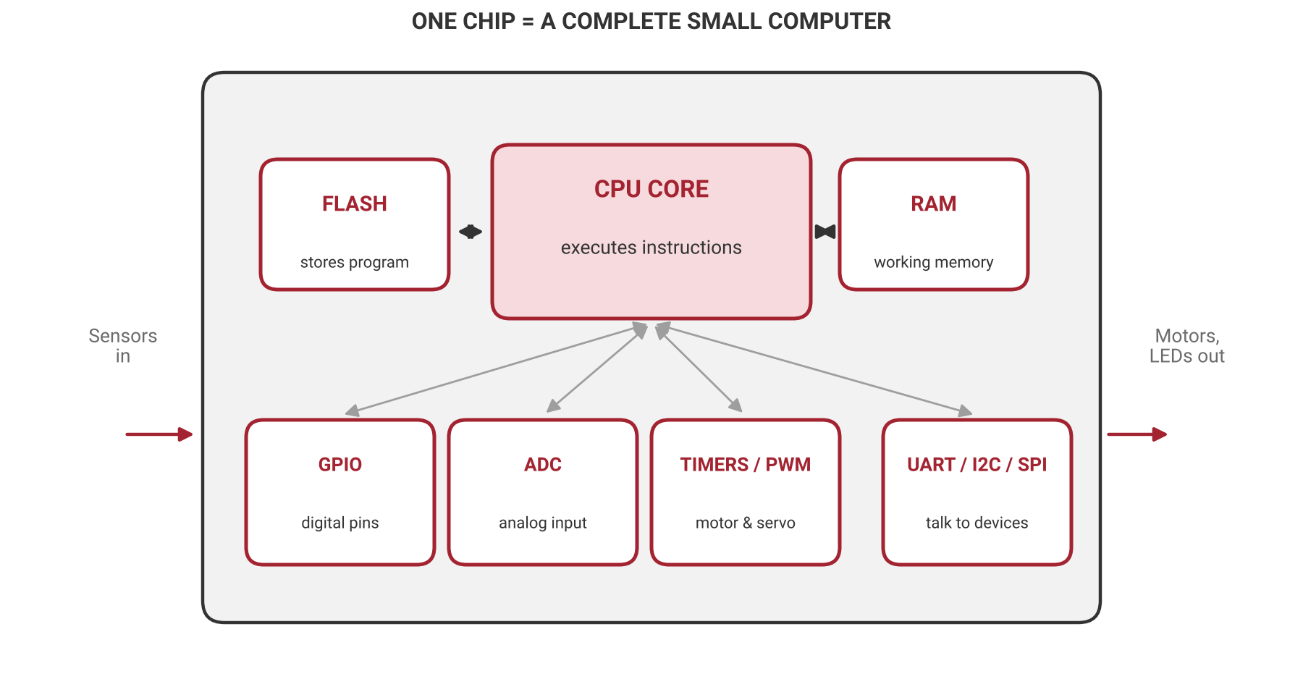
Figure 3.1: Inside a microcontroller: the CPU core, memories and peripherals that connect to sensors and actuators.

3.2 Key Building Blocks and Terms
- CPU core and bit width – the processor executes instructions; an 8-bit core handles data 8 bits at a time, while a 32-bit core handles larger numbers and complex calculations far faster.
- Clock speed – how many cycles per second the core runs, measured in megahertz (MHz).
- Flash memory – stores the program permanently, even when power is removed.
- RAM (SRAM) – temporary working memory for variables while the program runs.
- GPIO (General-Purpose Input/Output) – pins that read digital inputs such as buttons or drive digital outputs such as LEDs.
- ADC (Analogue-to-Digital Converter) – turns a varying voltage from an analogue sensor into a number.
- Timers and PWM (Pulse-Width Modulation) – generate precisely timed pulses used to set motor speed and servo angle.
- Communication interfaces – UART (serial), I²C and SPI link the microcontroller to sensors, displays, other boards and computers.
- Operating voltage – many classic boards use 5 V logic, while most modern chips use 3.3 V; mixing them without care can damage components.

3.3 Microcontroller, Microprocessor or Single-Board Computer?
Feature | Microcontroller (MCU) | Microprocessor (MPU) | Single-board computer (SBC)
What it is | CPU, memory, and I/O on one chip | CPU only; needs external memory and chips | A full computer on one board built around an MPU
Operating system | Usually none (bare-metal program) | Runs an OS such as Linux or Windows | Runs Linux or similar
Response timing | Very predictable, microseconds | Depends on the OS | Less predictable (not real-time)
Power and cost | Very low | Higher | Moderate
Robot role | Motor control, sensor reading | Laptops, desktops, servers | Vision, planning, networking, apps
Example | Arduino Uno, ESP32 | Intel and AMD processors | Raspberry Pi

3.4 Popular Microcontroller Families
Robotics engineers meet a small number of microcontroller families again and again. Each balances speed, connectivity, cost, and ease of use differently.
Family (example board) | Core and clock | Memory | Strengths | Typical robot use
AVR – Arduino Uno (ATmega328P) | 8-bit, 16 MHz | 32 KB flash, 2 KB RAM | Simplest to learn, huge community | Beginner robots, simple sensor projects
AVR – Arduino Mega (ATmega2560) | 8-bit, 16 MHz | 256 KB flash, 8 KB RAM | Many I/O pins | Robots with many sensors and motors
ESP32 (Espressif) | 32-bit dual-core, up to 240 MHz | About 520 KB RAM | Built-in Wi-Fi and Bluetooth, low cost | App-controlled and IoT robots
STM32 (STMicroelectronics) | 32-bit ARM Cortex-M (M0 to M7) | Wide range | Industrial grade, precise timers, many variants | Motor drivers, drones, commercial products
RP2040 (Raspberry Pi Pico) | 32-bit dual Cortex-M0+, 133 MHz | 264 KB RAM | Very low cost, programmable I/O | Servo and LED control, education
PIC (Microchip) | 8, 16 and 32-bit options | Wide range | Long industry history, low power | Appliances, industrial controllers

3.5 Beyond Microcontrollers: SBCs and Edge-AI Modules
As robots take on cameras, maps, and artificial intelligence, a microcontroller alone is not enough. Most modern robots therefore use a layered computing architecture: a microcontroller handles fast, time-critical reflexes, a single-board computer handles planning and networking, and in AI-heavy robots an edge-AI module runs neural networks directly on the robot.
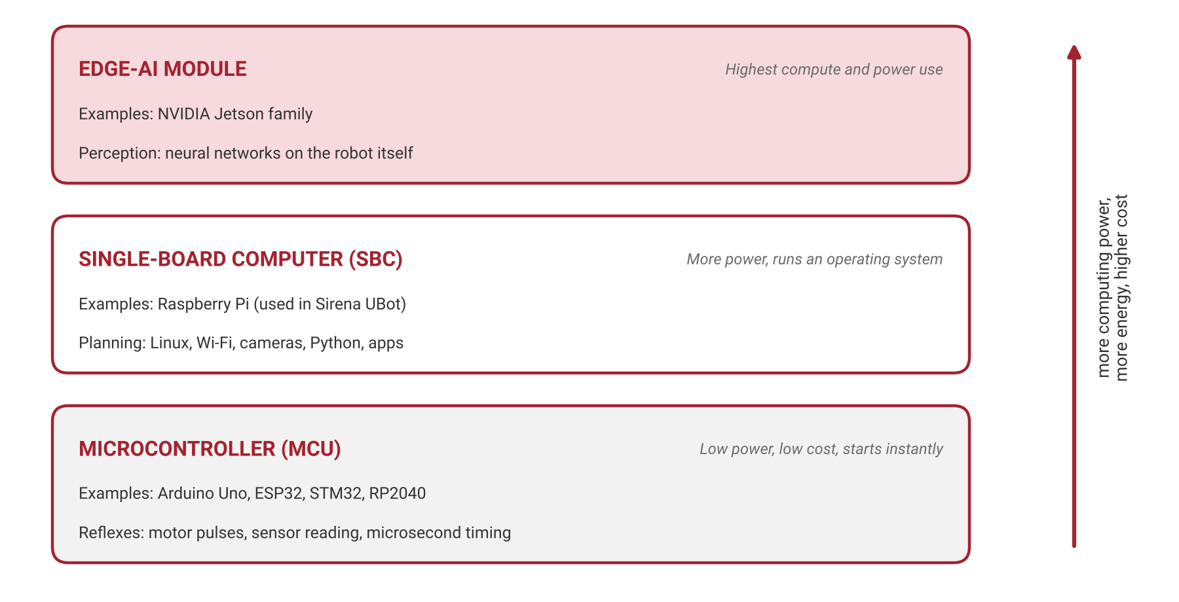
Figure 3.2: The three layers of robot computing, from low-power microcontrollers to edge-AI modules.
Edge AI means running AI models on the robot itself rather than sending data to a remote cloud server. It gives faster responses, works without an internet connection, and keeps camera data private.
3.6 How to Choose a Controller for a Robot
Choosing a controller is a real engineering decision with consequences for cost, battery life and capability. A structured comparison helps avoid both overspending and underpowering.
- Task complexity – blinking lights and reading a distance sensor need only an 8-bit MCU; camera-based navigation needs an SBC or edge-AI module.
- Number of inputs and outputs – count the sensors, motors and servos the robot needs.
- Connectivity – wireless app control points to an ESP32 or an SBC with Wi-Fi.
- Timing – precise motor and servo control favours an MCU with hardware timers.
- Power budget – battery-powered robots must balance performance against run time.
- Cost and ecosystem – community support, documentation and available libraries reduce development time.
Engineers often record these criteria in a weighted decision matrix, giving each criterion an importance weight and scoring each candidate board, so that the choice is transparent and can be defended.

4. Types of Robots
Robots can be classified in several ways: by how they move (fixed, wheeled, legged, flying, swimming), by where they work (factory, warehouse, home, hospital, outdoors) and by what they do (manipulation, transport, inspection, interaction). This section uses the most common beginner classification by body plan: wheeled, legged, humanoid and industrial robots.

4.1 Wheeled Robots
Wheeled robots are the most common mobile robots because wheels are mechanically simple, energy-efficient, and naturally stable. Their main limitation is terrain: wheels struggle with stairs, deep gaps, and very rough ground. The way the wheels are arranged, called the drive configuration, decides how the robot can move and turn.
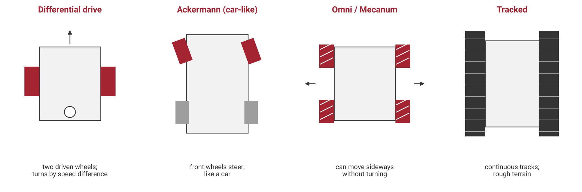
Figure 4.1: Common wheeled drive configurations seen from above.
- Differential drive – two independently driven wheels plus a caster. Equal speeds drive straight; unequal speeds turn; opposite speeds spin on the spot. This is the most common design for small and indoor robots.
- Ackermann steering – car-like steering of the front wheels; stable at speed but cannot turn on the spot.
- Omni and mecanum wheels – rollers set around the wheel rim let the robot slide sideways without turning, which is useful in tight warehouse aisles.
- Tracked (skid-steer) – continuous tracks spread the weight and grip rough ground, used in inspection and defence robots.
Sirena's UBot is a wheeled service robot with an indoor base optimised for stability and precise movement in hallways and rooms (Section 6.3).

4.2 Legged Robots
Legged robots step over obstacles, climb stairs, and cross uneven ground that would stop a wheeled robot. The price is complexity: each leg needs several motorised joints, and the robot must manage its balance at every moment. Common legged designs are quadrupeds (four legs, like Sirena's Perro), hexapods and multi-legged robots (like Sirena's Twist) and bipeds (two legs).
A key idea is the support polygon: the area on the ground enclosed by the feet in contact with it. A robot is statically stable if its centre of mass stays above this polygon, meaning it would not fall even if it froze mid-step. A hexapod using a tripod gait always keeps three feet down and is statically stable. A quadruped crawl gait lifts one leg at a time and is stable at slow speeds, while a trot (diagonal legs moving together) is dynamically stable: it stays upright only because it keeps moving. A biped standing on one foot has a very small support area and must balance actively.
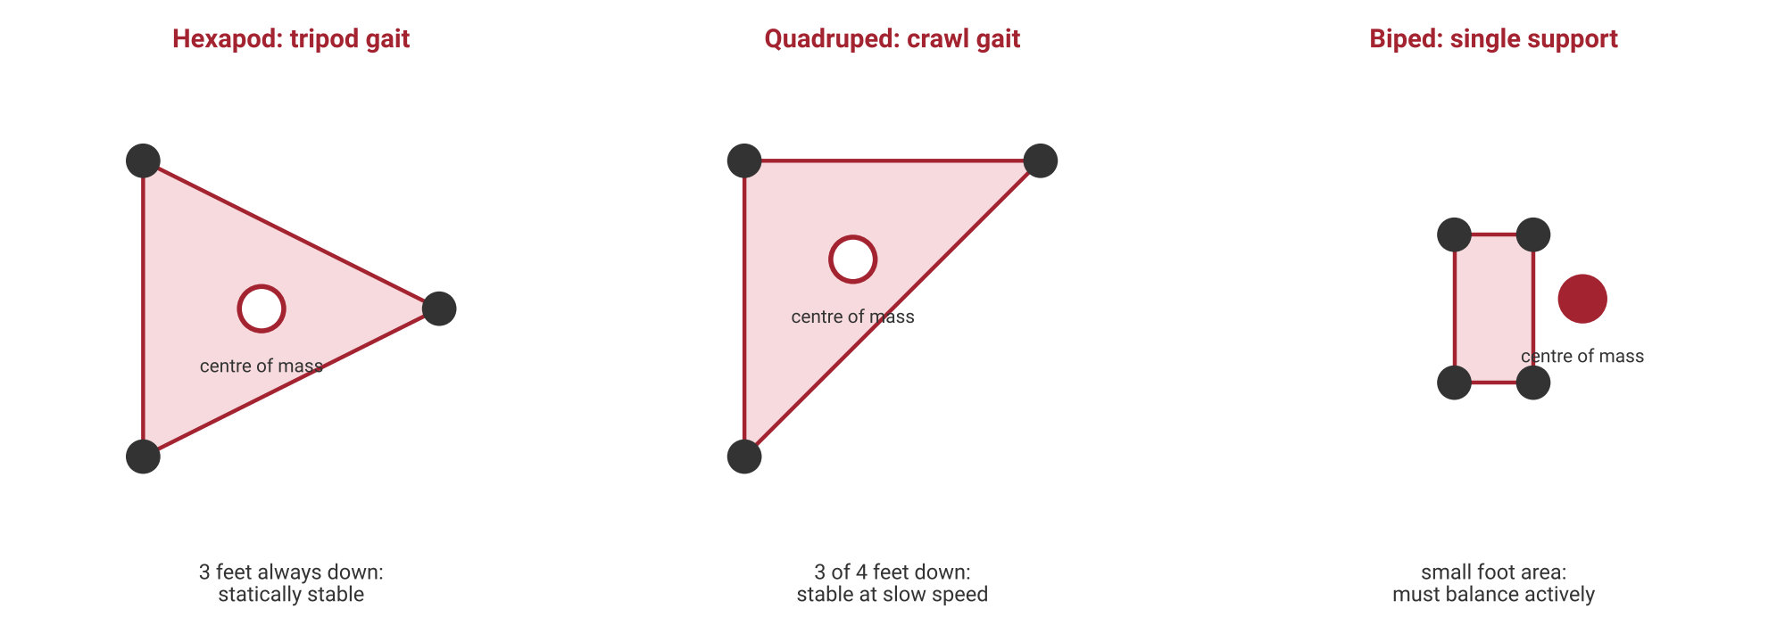
Figure 4.2: Support polygons: more feet on the ground give a larger area for the centre of mass to stay above.
Small legged robots are often programmed using keyframes: a sequence of poses, each storing a target angle for every joint motor, which the controller plays back by moving smoothly from one pose to the next. This is exactly how custom actions are recorded on Sirena's Perro and Twist robots.

4.3 Humanoid Robots
A humanoid robot has a human-like body: a head, torso, two arms, and usually two legs. Humanoids are built because they can work in spaces designed for people – stairs, doors, desks, tools – and because people find it natural to interact with them. They are widely used in education, research, reception and customer service, and increasingly in pilot projects in factories and warehouses.
A humanoid combines several subsystems: legs for walking and balance, arms and hands for gestures and manipulation, a head containing cameras, microphones and speakers for perception and conversation, and an interaction layer such as displays, touch sensors and voice recognition. Walking humanoids are commonly balanced using the Zero Moment Point (ZMP) principle: the controller keeps the point at which the ground's reaction force acts inside the foot's support area, so the robot does not tip over.
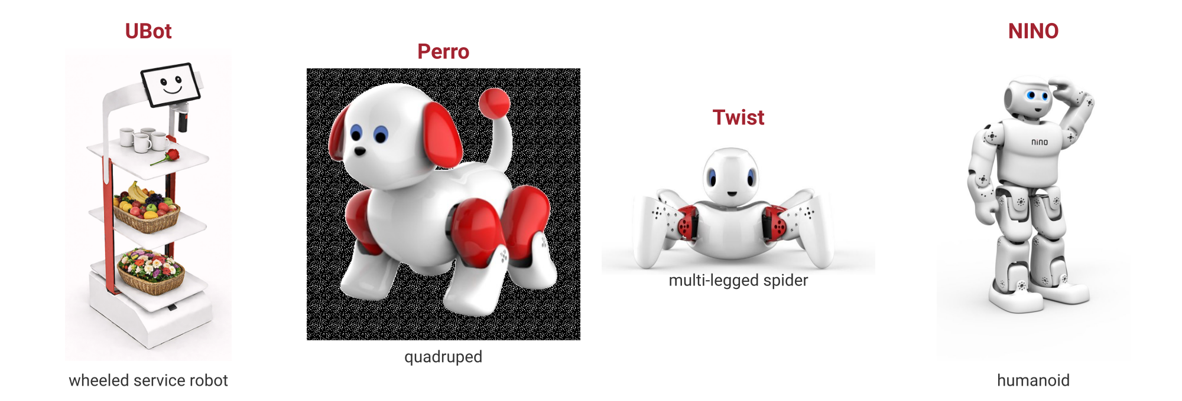
Figure 4.3: Sirena's robot fleet covers every family in this section: wheeled (UBot), quadruped (Perro), multi-legged (Twist) and humanoid (NINO).

4.4 Industrial Robots
Industrial robots are programmable manipulators that work in factories, performing welding, painting, assembly, packaging, palletising and machine tending. They are fixed to the floor, a table or a ceiling, and they are judged by payload (the mass they can carry), reach (how far they extend), repeatability (how precisely they return to the same point) and speed.
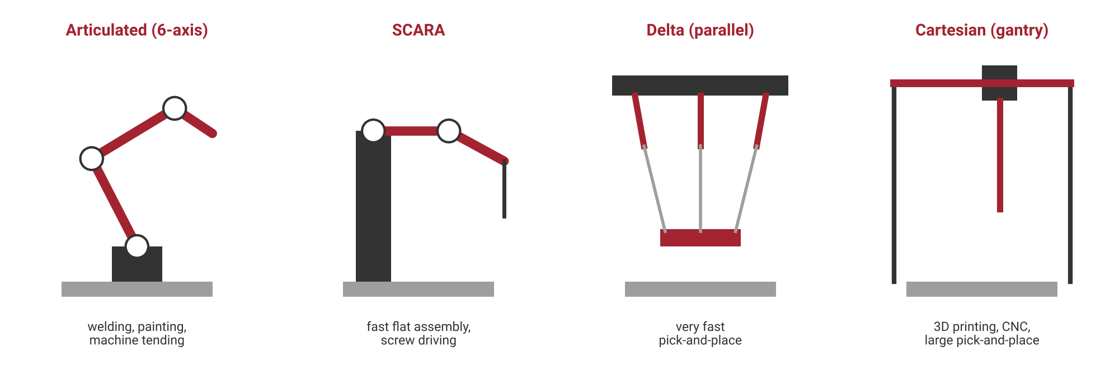
Figure 4.4: Main types of industrial robot arms and their typical tasks.
- Articulated arms – rotary joints like a human arm, usually with six DOF; the most flexible and widely used type.
- SCARA – rigid vertically and flexible horizontally; very fast for flat assembly tasks such as placing components and driving screws.
- Delta (parallel) robots – three light arms joined at a single platform; extremely fast pick-and-place, common in food and pharmaceutical packaging.
- Cartesian (gantry) robots – move along straight X, Y and Z axes; simple and accurate, used in 3D printers, CNC machines and large pick-and-place systems.
Collaborative robots (cobots) are designed to work safely beside people without safety cages. They limit their speed and force and stop when they detect contact, which makes automation affordable for small and medium factories. The position of a robot arm's tool is calculated from its joint angles by forward kinematics, a topic covered in detail in later modules.

4.5 Comparing Robot Families
Family | Moves by | Stability | Main strengths | Main limits | Sirena example
Wheeled | Rolling | High, passive | Efficient, simple, fast on flat floors | Stairs and rough ground | UBot
Quadruped | Four legs | Static or dynamic | Rough terrain, stable stance | More motors, complex control | Perro
Multi-legged | Six or more legs | Very high, static | Very stable walking | Slower, many motors | Twist
Biped | Two legs | Low, active balance | Human spaces, research value | Hardest to balance | Biped platform
Humanoid | Two legs plus arms | Low, active balance | Interaction, versatility | Cost, power use, complexity | NINO
Industrial arm | Fixed base, joints | Very high (bolted) | Precision, speed, payload | Works in one place | –

4.6 Other Robot Types
Beyond these four families, learners will meet aerial robots (drones) used for inspection, mapping and delivery; underwater robots for pipeline and ship-hull inspection; space robots such as planetary rovers; soft robots made of flexible materials for safe gripping; and swarm robots, in which many simple robots cooperate. India's Chandrayaan-3 mission, for example, placed the Pragyan rover on the Moon in 2023.

5. Robotics Industry Overview

5.1 How the Industry Is Organised
The robotics industry is best understood as a value chain: a series of businesses that each add value before a robot does useful work for a customer. Engineers can build careers at every stage.
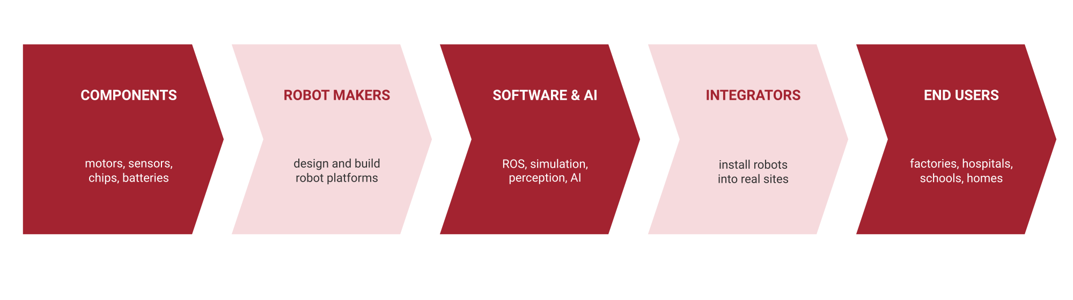
Figure 5.1: The robotics value chain from components to end users.
- Component makers produce motors, gearboxes, sensors, cameras, chips and batteries.
- Robot makers design and build complete robot platforms such as arms, mobile robots and humanoids.
- Software and AI companies provide operating systems, simulation tools, perception and AI models; open-source software such as ROS is widely used.
- System integrators design complete solutions and install robots into a customer's factory, warehouse or hospital.
- End users operate the robots and maintain them, often through service contracts or robots-as-a-service (RaaS) rental models.

5.2 Market Segments
Robots are sold into very different markets, each with its own customers, priorities and required skills. The International Federation of Robotics (IFR) publishes the most widely cited annual statistics; its World Robotics reports show more than half a million new industrial robots being installed worldwide each year in recent years, with Asia, led by China, the largest market.
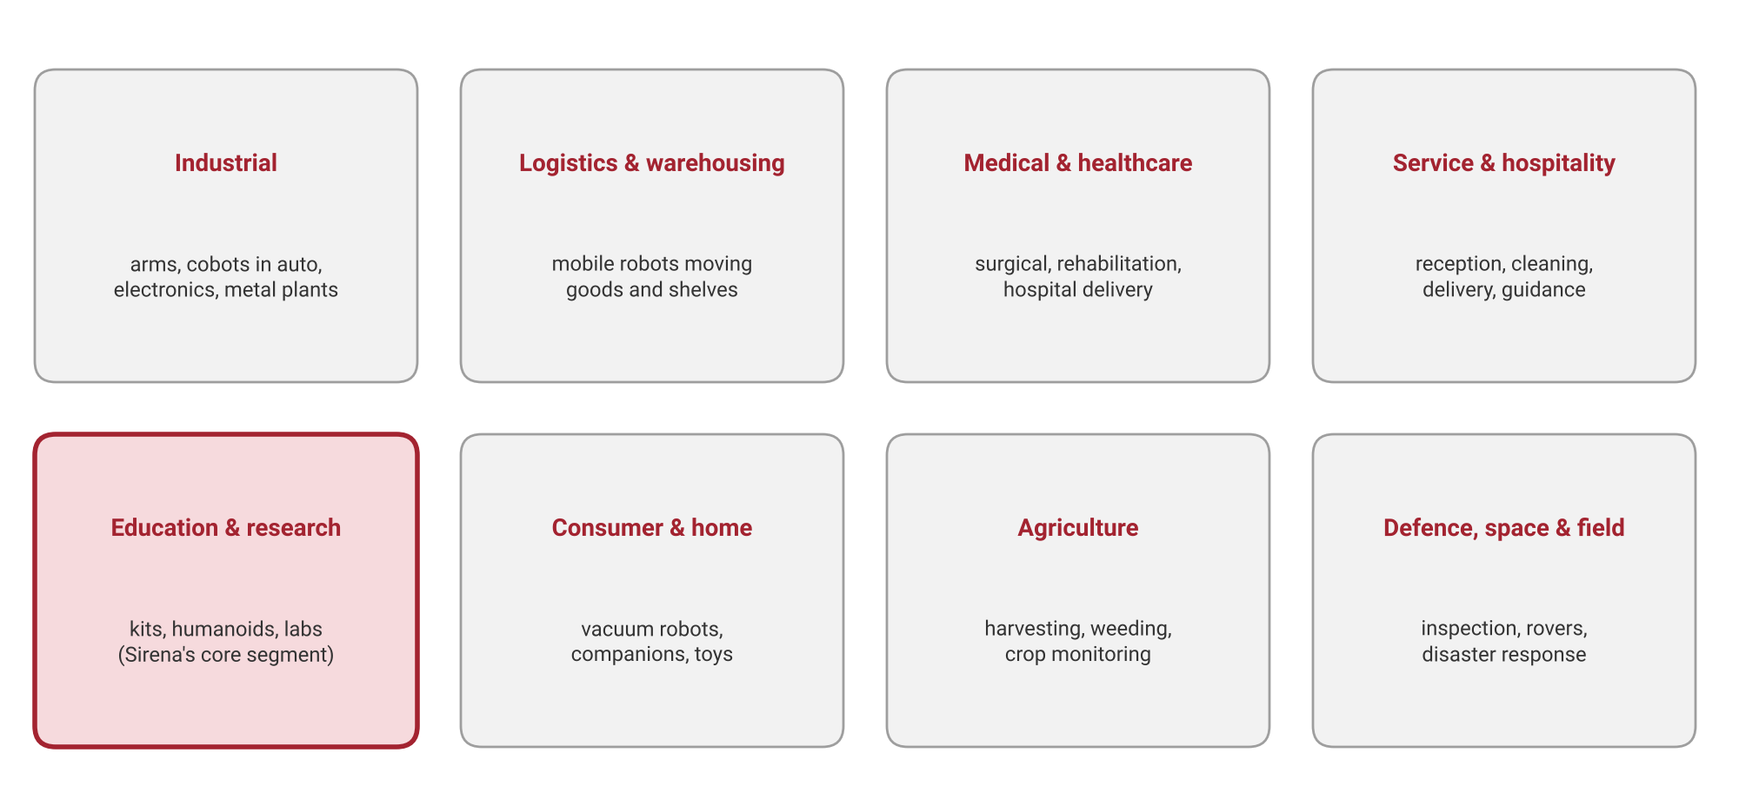
Figure 5.2: Main segments of the robotics industry. Education and research, Sirena's core segment, is highlighted.

5.3 Major Players
Segment | Well-known companies | Example products
Industrial arms | FANUC, ABB, Yaskawa, KUKA | Six-axis arms, welding and painting robots
Collaborative robots | Universal Robots, FANUC, ABB | Cobots for small factories
Logistics and warehousing | Amazon Robotics, GreyOrange, Addverb, Geek+ | Goods-to-person mobile robots, sorting systems
Medical | Intuitive Surgical | da Vinci surgical system
Consumer | iRobot and others | Robot vacuum cleaners
Legged and humanoid | Boston Dynamics, Unitree, Agility Robotics, Figure | Spot, Atlas, Digit, humanoid pilots
Industrial mobility (India) | Ati Motors | Autonomous industrial vehicles
Education and research | Sirena Technologies, LEGO Education | NINO, Perro, Twist, UBot; learning kits

5.4 Key Trends Shaping the Industry
- Humanoids moving from demonstrations to pilots – several companies are testing humanoids in factories and warehouses.
- AI foundation models for robots – vision-language-action models let robots follow plain-language instructions and generalise to new tasks.
- Edge AI – more perception and decision-making runs on the robot itself using embedded AI processors.
- Collaborative robots and robots-as-a-service – lower cost and rental models make automation accessible to small businesses.
- Simulation-first development – ROS 2 and simulators such as Gazebo allow robots to be designed and tested virtually before hardware is built.
- Safety and standards – as robots work closer to people, safety standards, ethics, and regulation grow in importance.

5.5 Robotics in India
India's robotics sector is growing on several fronts: automation in automotive and electronics manufacturing; warehouse automation driven by e-commerce, with Indian-origin companies such as GreyOrange and Addverb; autonomous industrial vehicles from start-ups such as Bengaluru's Ati Motors; space robotics through ISRO; and robotics education, where companies such as Sirena Technologies supply humanoid, legged and wheeled platforms to schools and engineering colleges. Government initiatives that promote domestic manufacturing increase demand for engineers who can install, program, and maintain robots.

5.6 Careers in Robotics
Role | What they do | Core skills
Robotics technician | Build, maintain and calibrate robots | Electronics, assembly, troubleshooting
Embedded systems engineer | Write firmware for controllers and motor drivers | C/C++, microcontrollers, communication protocols
Robotics software engineer | Develop navigation, planning, and control software | Python, C++, Linux, ROS
Perception / AI engineer | Give robots vision and intelligence | Computer vision, machine learning, edge AI
Mechanical design engineer | Design robot structures and mechanisms | CAD, kinematics, materials
Controls engineer | Design balance, gait, and motor control | Control theory, mathematics, dynamics
Field application engineer | Deploy and support robots at customer sites | Systems thinking, communication, debugging
Robotics product manager | Decide what robot to build and for whom | Market understanding, technical breadth

6. Sirena Technologies Product Ecosystem

6.1 About Sirena Technologies
Sirena Technologies is a Bengaluru-based company founded with the vision of bringing innovative, world-class products to market that are designed and developed in India. It describes itself as the first Indian company to build an intelligent humanoid robot, NINO. While the company works across artificial intelligence and IoT, its primary focus is education.
Sirena delivers this through two programmes: SKIP (Sirena Knowledge and Information Program), integrated with school curricula from kindergarten to higher grades, and SKIP-E (Sirena Knowledge and Information Program – Engineering), for technical universities. Together they aim to build a learning ecosystem in IoT and advanced robotics that encourages creativity, research and experimentation.

6.2 The Ecosystem at a Glance
The Sirena product ecosystem was designed so that a learner can experience every major robot family from Section 4 on real hardware.
Platform | Robot family | Key hardware | How it is controlled | Main learning value
UBot | Wheeled service robot | Raspberry Pi main controller, indoor mobile base, RGB LED and buzzer | Android app over Wi-Fi; PC terminal via UART/HDMI | Mobile robots, SBCs, real-world deployment
NINO | Humanoid | 20 smart servos, camera, 3 microphones, 2 speakers, IMU, IR and touch sensors | Sirena Studio, Android app, Python, C# | Humanoid design, perception, interaction, AI
Perro | Quadruped | 12 servo motors, optional USB camera | Android app over Wi-Fi with frame recording | Gaits, legged locomotion, keyframes
Twist | Multi-legged (spider) | 12 motors, predefined actions | Android app with frame editing and group control | Static stability, choreography
Biped | Two-legged | Leg joints with servo actuators | Sirena software tools | Balance, walking, ZMP
Humanoid platforms | Humanoid | Full-body actuated platforms | Sirena software tools | Advanced humanoid robotics

6.3 UBot – Utility Robot
UBot (Utility Bot) is an autonomous and semi-autonomous service robot designed to streamline logistics in professional and academic environments. It serves as a delivery assistant that can carry files, refreshments and utility items, and it has been deployed at Shoolini University for campus logistics. Its design objective is to provide an efficient, robust and interactive mobile platform that reduces manual effort and increases operational efficiency.
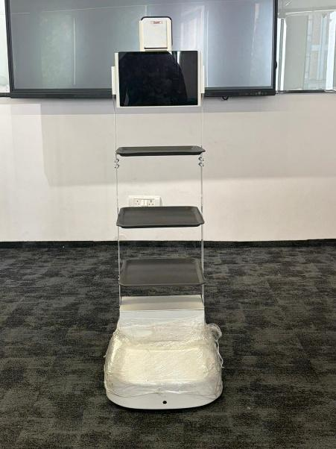
Figure 6.1: Sirena UBot, a wheeled utility robot for indoor delivery and logistics.
- Controller: a Raspberry Pi single-board computer housed in the electronics box acts as the main controller.
- Mobility: an optimised indoor wheeled base for stable, precise movement in hallways and rooms.
- Control: a custom Android application connects over a Wi-Fi hotspot and provides forward, back, left, right and stop commands.
- Feedback: an RGB LED and a buzzer show status – blinking green when ready to connect, solid green when connected, and red for low battery or an error.
- Power and service: a miniature circuit breaker (MCB) switches the robot on and off, and a UART/HDMI connection lets engineers configure it from a PC.
UBot connects directly to the theory in this module: it is a wheeled robot (Section 4.1), it uses a single-board computer as its brain (Section 3.5), and it is a real example of the logistics and service segment of the industry (Section 5.2).

6.4 NINO – Humanoid Robot
NINO is Sirena's intelligent humanoid robot and the flagship of the ecosystem. It is designed for education, research and human–robot interaction, and it brings together almost every concept in this module: actuators, sensors, embedded computing, balance and artificial intelligence.
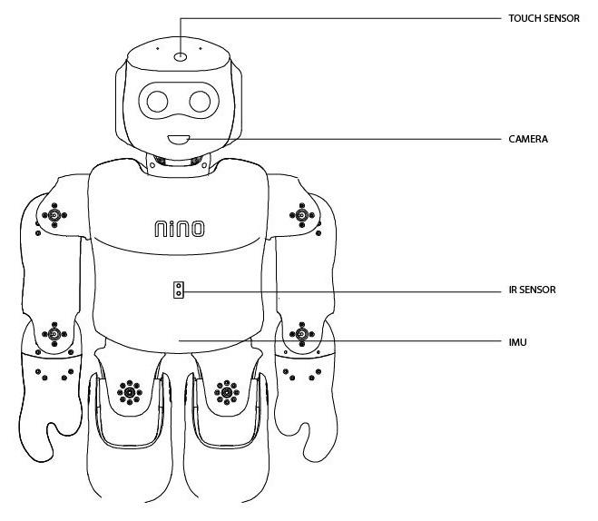
Figure 6.2: Sensor locations on NINO, including the touch sensor, camera, IR sensor and IMU.
Subsystem | NINO (V3) specification
Size and weight | 53.6 cm tall, about 3 kg
Controller | NINO Module CPU board (Sirena's in-house processor) plus an I/O and power board; Linux-derived operating system
Actuators | 20 Dynamixel smart servos: MX-28 servos for motors M1–M12 and AX-18 servos for motors M13–M20
Sensors | Capacitive touch sensor (head), IR distance sensor (chest, 4–50 cm), 9-axis IMU (torso)
Vision and audio | HD camera, 3 far-field microphones, 2 speakers, 2 small LCD displays
Power | Two rechargeable lithium-ion battery packs (3,400 mAh each)
Connectivity | Wi-Fi and USB
Software support | Sirena Studio, Android, Python, C#, MATLAB, V-REP simulation

The IMU combines accelerometer and gyroscope readings to estimate the torso angle, which is essential for balance. The IR sensor detects obstacles, the touch sensor provides a simple interaction input, and the camera supports computer-vision tasks such as object and face recognition. NINO responds to a spoken hot-word and can speak through its speakers, making it a platform for both robotics and conversational AI.
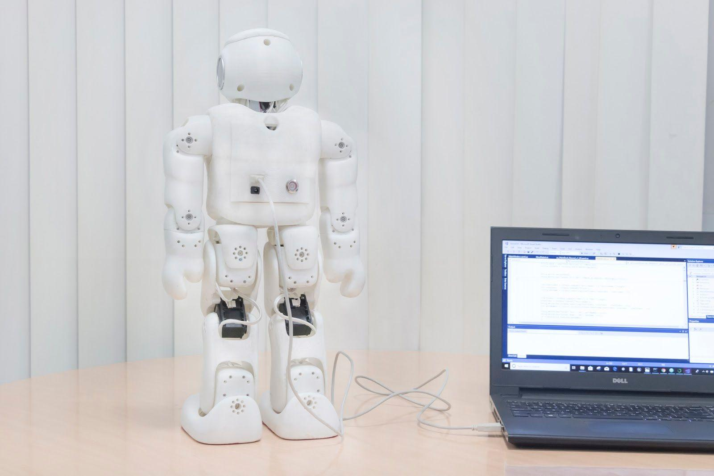
Figure 6.3: NINO connected to a computer for programming and action design.

6.5 Perro – Quadruped Robot
Perro is Sirena's quadruped (four-legged) robot, designed for interactive and programmable movement in education, research and entertainment. Its 12 servo motors (M1–M12), three per leg, allow it to walk, turn and hold postures.
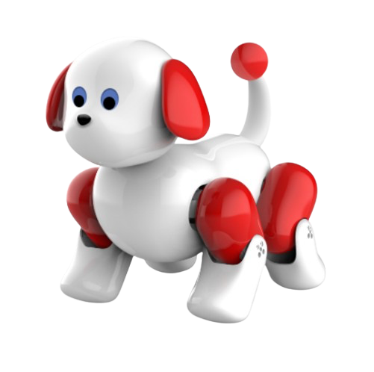
Figure 6.4: Sirena Perro, a 12-servo quadruped robot.
- Posture control: Sit, Stand and Neutral postures with a single tap.
- Movement: walking forward, backward, left and right; 90° rotations; tilting the body in four directions; adjustable speed.
- Camera feed: a compatible USB camera streams a live view to the app.
- Action recording: users create named actions made of frames, where each frame stores an angle for every motor, and play them back in sequence – the keyframe method described in Section 4.2.

6.6 Twist – Multi-Legged Robot
Twist is a multi-legged "spider" robot whose objective is to provide an efficient, robust and interactive platform for education and research in robotics, controls, IoT and programming. It uses 12 motors and offers a library of predefined actions such as wakeup, greet, happy, yoga and walking stance.
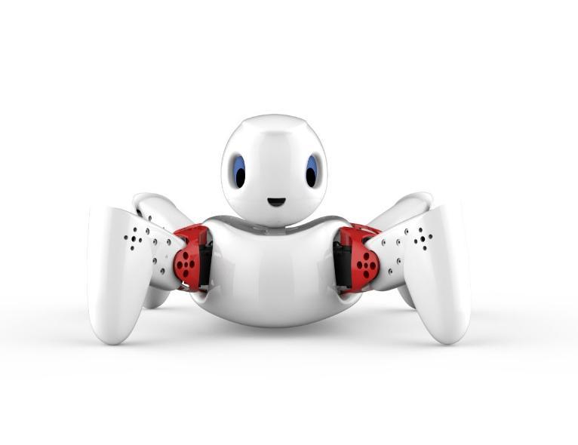
Figure 6.5: Sirena Twist, a multi-legged robot used to study stable walking and motion design.
Twist's app adds advanced motion-design tools: group control applies one angle to several motors at once for symmetric movements, frames can be edited and reordered by drag-and-drop, and actions can be saved, loaded and replayed. Because it walks with many legs, Twist is an excellent platform for understanding static stability and gait design.

6.7 Biped and Humanoid Platforms
The biped platform concentrates on the hardest problem in legged robotics: walking on two legs. With only two feet, and often just one on the ground, the support area is small, so the robot must actively control its centre of mass. Biped platforms are used to teach leg kinematics, gait cycles, centre-of-mass control and the ZMP balance principle before learners move to full humanoids.
Sirena's humanoid platforms, led by NINO, combine legs, arms, head sensors and AI into one system. They are used in advanced modules on humanoid design philosophy, degrees of freedom, humanoid kinematics, power distribution and electronics, and AI-driven interaction. Exact configurations of the biped and larger humanoid research platforms are provided in Sirena's platform documentation.

6.8 How the Ecosystem Supports the Learning Path
Platform | Concepts demonstrated | Later modules that build on it
UBot | Wheeled mobility, SBC control, wireless apps, service robotics | Raspberry Pi, Linux, ROS, autonomous navigation
Perro | Quadruped gaits, servo control, keyframe actions | Actuators, quadruped kinematics and locomotion
Twist | Static stability, multi-leg coordination, motion design | Sensors, actuators, gait design
Biped | Two-legged balance, centre of mass, ZMP | Kinematics, humanoid robotics
NINO and humanoid platforms | Full-body control, perception, voice and AI interaction | Humanoid robotics, computer vision, generative AI, reinforcement learning

7. Summary and Review

7.1 Key Takeaways
- A robot senses, thinks and acts with some independence; if a human does the thinking, it is teleoperation, and if it only follows a fixed sequence, it is automation.
- Every robot is built from a controller, sensors, actuators, a power supply, a mechanical body, and software and communication.
- Robotics advanced by removing bottlenecks in actuation, computing, sensing and balance; industrial arms came first and humanoids most recently.
- Microcontrollers handle fast, low-power control; single-board computers handle planning and networking; edge-AI modules run neural networks on the robot.
- Wheeled robots are efficient on flat floors, legged robots handle rough terrain, humanoids suit human spaces and interaction, and industrial arms deliver precision and speed in fixed cells.
- The robotics industry runs from components to robot makers, software, integrators and end users, with growing roles in India.
- Sirena's ecosystem – UBot, NINO, Perro, Twist, biped and humanoid platforms – lets learners study every major robot family on real hardware.

7.2 Glossary
Term | Meaning
Actuator | A device that creates motion or output, such as a motor or servo
Autonomy | The degree to which a robot acts without human control
Centre of mass | The point where a body's mass can be considered to act
Cobot | A collaborative robot designed to work safely beside people
Degree of freedom (DOF) | One independent direction or axis in which a robot can move
Edge AI | Running AI models on the robot rather than in the cloud
GPIO | General-purpose input/output pins on a microcontroller
IMU | Inertial measurement unit; senses acceleration and rotation
Keyframe | A stored pose of all joint angles used to build a motion sequence
Microcontroller (MCU) | A complete small computer on a single chip
PWM | Pulse-width modulation; a method of controlling motor speed and servo angle
ROS | Robot Operating System; an open-source software framework for robots
Single-board computer (SBC) | A complete computer on one circuit board, such as a Raspberry Pi
Support polygon | The ground area enclosed by a robot's feet in contact with the ground
Zero Moment Point (ZMP) | The point that must stay inside the support area for a walking robot to stay balanced

7.3 Review Questions
- Define a robot using the sense–think–act model, and explain why a remote-controlled car is not a fully autonomous robot.
- List the six main building blocks of a robot and give one example of each.
- Why did the first industrial robot, Unimate, appear in a car factory? Relate your answer to the three Ds.
- Name two technologies that made dynamic legged walking practical, and give one robot from each of the industrial, mobile and humanoid eras.
- Explain the difference between a microcontroller and a single-board computer, with one robot task suited to each.
- Compare the Arduino Uno and the ESP32 on bit width, clock speed and connectivity. Which would you choose for an app-controlled robot, and why?
- Explain the support polygon. Why is a tripod-gait hexapod more stable than a trotting quadruped?
- Describe four types of industrial robot arm and one typical task for each.
- Draw the robotics value chain and identify where a system integrator fits.
- For each Sirena platform – UBot, NINO, Perro, Twist and the biped – name its robot family and one concept it helps students learn.

